Chat gpt chat
What you're describing is a reusable procedural map generation framework with a custom Unity Inspector. Instead of building a generator that only works for your tank game, you want to build a system where you configure generation rules in the Inspector and reuse the underlying framework in other 2D games.
That's a worthwhile system-design exercise because it forces you to separate what a map is, how it gets generated, and how the generated map gets displayed.
The important distinction is that a custom Inspector is not the map generator itself. It's the control panel through which you configure, test, and debug the generator. The actual generation logic should work independently of the Unity Editor.
1. What we're actually building
I'd design this as a small reusable tool called Procedural2DMapGenerator.
Custom Inspector
Seed, map dimensions, generation algorithm, rules, preview and validation
Generation Core
Algorithms, grid data, placement rules and validation
Map Data
Walkable cells, walls, obstacles and spawn locations
Map Renderer
Tilemaps, sprites, prefabs and scene objects
Conceptual architecture, not a finished implementation.
The framework should eventually support games such as:
- Top-down tank games with walls, cover and enemy spawn points.
- Dungeon games with rooms and corridors.
- Survival games with resource and obstacle placement.
- Grid-based strategy games with different terrain types.
These games share some map-generation problems, but they don't share every generation rule. Our design must account for that without becoming a giant framework that tries to solve the entire universe.
2. What the custom Inspector should look like
Here's a possible first version of the tool's interface.
Procedural 2D Map Generator
Generation Settings
Prototype
Map Width
30 cells
Map Height
20 cells
Random Seed
12345
Algorithm
Random Placement
Generation Rules
Obstacle density
25%
Keep spawn zones clear
Ensure map connectivity
Map Preview
Ground
Obstacle
Boundary
Illustrative preview only. These controls are a mock-up, not a functioning Unity Inspector.
Regenerate
Validate Map
The preview is only a design reference. In Unity, we'd implement actual Inspector controls and a map preview using editor APIs.
3. How to implement it without getting lost
Build the system in layers. Don't start by writing a massive custom Inspector with twenty controls; that would give you a polished interface around an untested algorithm. A classic engineering trap.
- Phase 1: Define the map data
Create a grid representation independent of GameObjects. For example, each cell can store whether it is ground, a wall, an obstacle, or a spawn location.
Deliverable: generate a map in memory and inspect its cell values.
- Phase 2: Implement one generation algorithm
Start with seeded random obstacle placement. Given the same seed and settings, it should generate the same logical map.
Deliverable: a repeatable map-generation method that doesn't depend on the Unity Inspector.
- Phase 3: Add validation
Check whether the player spawn is clear, obstacles obey placement limits, and required areas are reachable.
Deliverable: a generator that can reject or correct an invalid map.
- Phase 4: Build the custom Inspector
Add editable settings, generation buttons, validation results, and a visual preview.
Deliverable: a usable editor tool rather than a collection of scripts that only you know how to operate.
- Phase 5: Separate rendering from generation
Render the same map data using your tank game's Tilemap or prefab setup. Later, another game can use a different renderer without rewriting the algorithm.
Deliverable: a reusable generation core with a game-specific rendering layer.
- Phase 6: Extend the framework
Add interchangeable algorithms, placement rules, configurable spawn regions, and additional validation as real requirements arise.
4. Suggested C# architecture
Keep the first version small:
Component | Responsibility
MapGenerationSettings | Stores dimensions, seed and generation parameters
MapData | Holds the logical grid and cell information
IMapGenerationAlgorithm | Defines a common contract for generation algorithms
RandomPlacementGenerator | Implements your first algorithm
MapValidator | Checks map constraints and connectivity
MapRenderer2D | Converts map data into Unity visuals
ProceduralMapGeneratorEditor | Implements the custom Inspector in an Editor folder
One useful design decision is to store settings in a ScriptableObject if you want reusable, saved generation profiles. The Inspector can edit that configuration, while the generation algorithm consumes it.
You don't need interfaces for every class. One algorithm interface is reasonable because supporting multiple algorithms is an explicit goal, not because every class needs an abstraction for its own amusement.
5. What makes it reusable across games?
The framework should expose a small set of stable concepts:
- Dimensions and seed: how large the map is and how randomness is controlled.
- Generation algorithm: how the logical layout is created.
- Placement rules: what can appear where.
- Validation rules: what makes a generated map acceptable.
- Rendering: how logical cells become visible game objects.
For instance, a tank game might define a rule that every spawn zone has a clear radius. A dungeon game might instead require all rooms to connect to the entrance. Those are different rules built on shared infrastructure.
There is one important limitation: a 2D grid generator is not automatically suitable for every possible 2D map. Freeform arenas, physics-based layouts, and continuous terrain need different representations or algorithms. Aim for a reusable grid-based 2D framework first, then expand when another concrete use case justifies it.
6. Your first implementation milestone
For your tank game, I'd start with only these requirements:
- Configure map width, height, and random seed.
- Generate a grid containing ground and obstacles.
- Reserve a safe player spawn zone.
- Validate the generated map.
- Preview it in the Unity Editor.
- Render it in the tank game.
Once that works, introduce a second generation algorithm to prove that your architecture is genuinely extensible.
The core principle: make the generator work without the Inspector first, then build the Inspector as a tool for configuring and testing it. That order will teach you more about implementation and system design than starting with editor UI and trying to fit the algorithm around it.
For your Brotato-inspired tank game, Procedural Content Generation (PCG) can make each run feel different without requiring you to manually design every battlefield. But randomizing the entire game would be a mistake. You want controlled randomness that creates interesting combat situations, not a battlefield that randomly decides to ruin the player's day.
Since your tank game already has movement, aiming, weapons, health, enemy spawning, and a wave system in progress, here's where PCG can add the most value.
1. Where PCG fits into your tank game
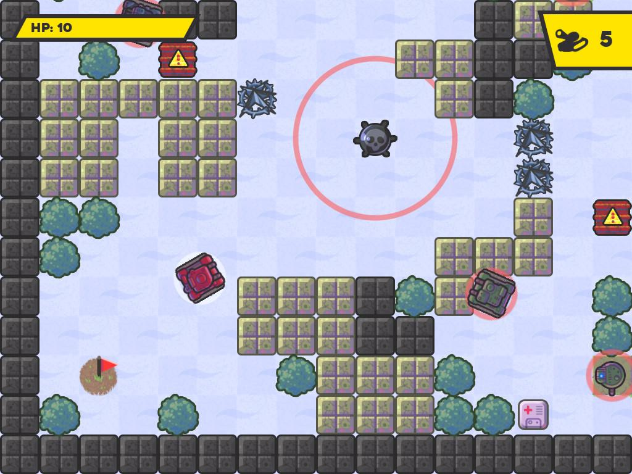
1. Procedural battlefield generation
Generate different arrangements of rocks, walls, crates, and open combat areas for each run.
- Keep the player spawn area clear.
- Maintain enough space for tank movement.
- Avoid creating walls that trap the player.
- Control obstacle density so aiming and dodging remain possible.
Highest priority
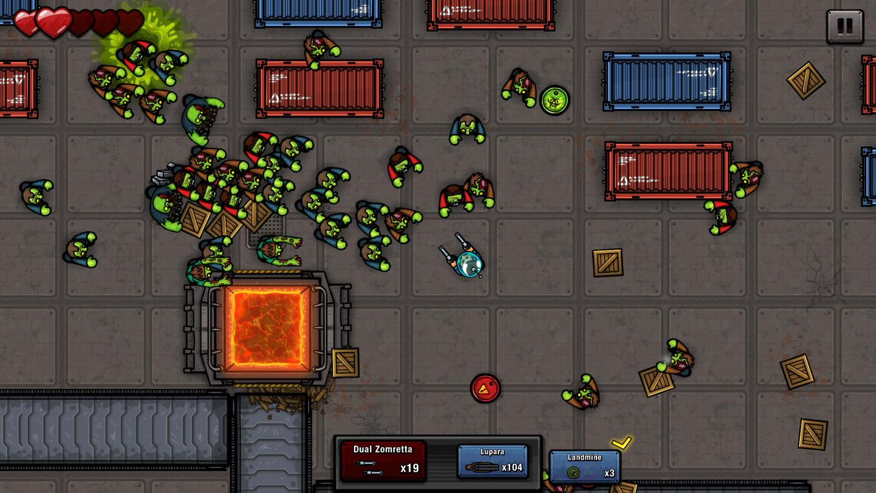
2. Procedural enemy spawn locations
Your existing SpawnManager and EnemySpawner can choose spawn positions based on the generated battlefield.
- Avoid spawning enemies inside obstacles.
- Maintain a minimum distance from the player.
- Prefer different directions instead of repeatedly spawning enemies in one corner.
- Increase pressure as a wave progresses.
Your spawn system already exists, so this is an extension rather than a complete rewrite.
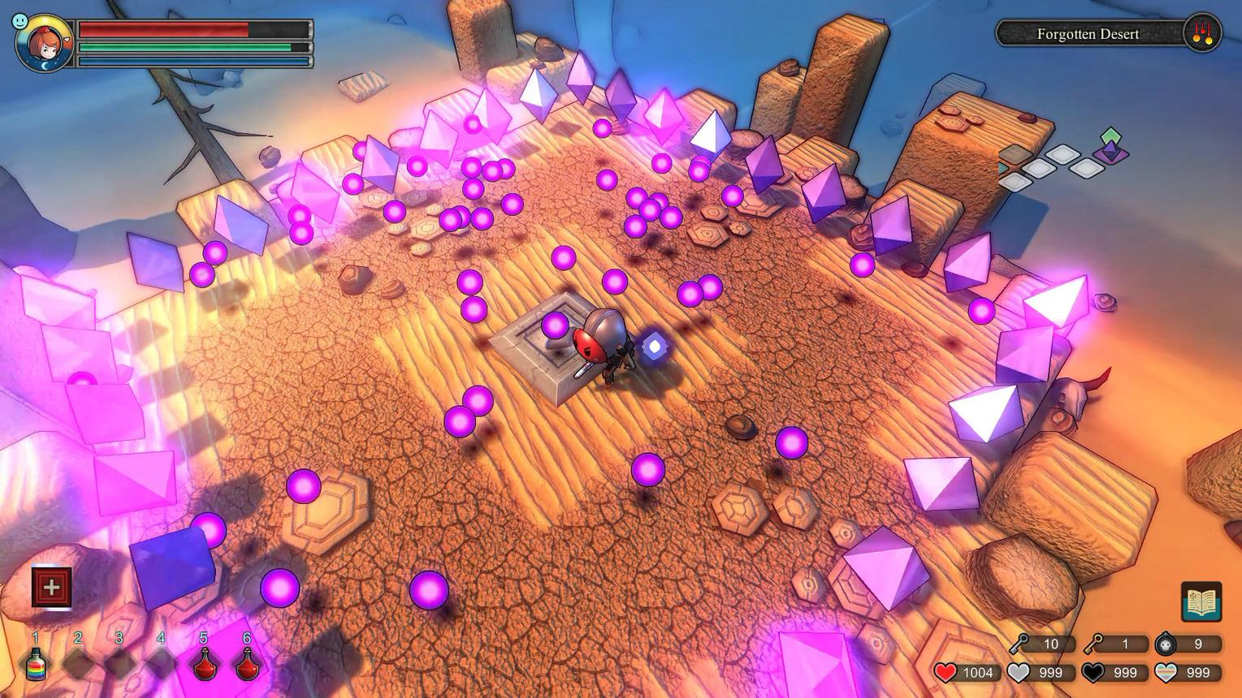
3. Procedural pickups and rewards
Spawn health pickups, experience items, ammunition, or temporary power-ups at controlled locations.
- Prevent pickups from appearing inside walls.
- Adjust drop chances by enemy type.
- Reward riskier areas with better opportunities.
- Keep pickup frequency balanced.
This connects map generation to your future progression system.
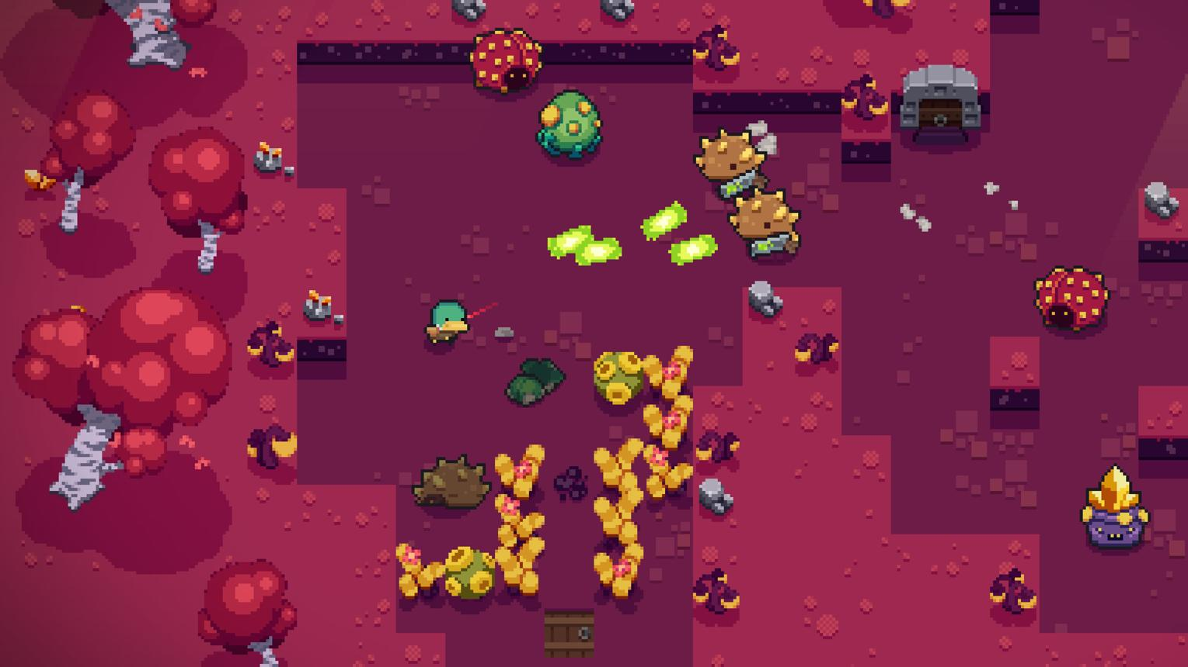
4. Procedural encounter layouts
Instead of changing only individual obstacle positions, generate different arena patterns.
Examples:
- Open arena with scattered cover.
- Several obstacle clusters creating narrow lanes.
- A central obstacle island.
- Outer cover with an open center.
These patterns change how the player moves, aims, and handles enemy groups.
2. How it connects to your existing systems
Your project shouldn't become one giant ProceduralMapGenerator script responsible for everything. Keep the responsibilities separate.
Procedural Map Generator
Creates the layout and valid placement locations
Map Renderer
Ground, obstacles, colliders
Spawn Point Data
Player, enemies, pickups
Existing Gameplay Systems
Tank movement · Aiming · Weapons · Enemy AI · Waves · Health
For example, your EnemySpawner should request a valid spawn location from the generated map rather than independently choosing a random point that happens to be inside a wall. That is the kind of integration where PCG becomes genuinely useful.
3. How PCG supports Brotato-style progression
Brotato's appeal isn't just a changing arena. Its replayability also comes from combat pressure, build choices, upgrades, and escalating waves.
You can gradually extend your tank game in three layers:
Layer | What changes | Example
Map generation | Battlefield layout | More cover or wider lanes
Encounter generation | Enemies and spawn patterns | Fast enemies from multiple directions
Run progression | Difficulty and rewards | More enemies, stronger variants, improved rewards
Keep the layers separate. A harder wave does not necessarily need a different map, and a different map does not automatically need stronger enemies.
4. What I'd implement first in your project
Given that your current generator is almost complete and you've kept it in a separate scene, I'd use this order:
- Integrate map generation into the main scene. Make sure it creates the expected ground and obstacles without interfering with your existing tank setup.
- Add map validation. Ensure the player has room to move and required spawn positions are reachable.
- Connect the enemy spawner. Use the generated map to find valid spawn locations.
- Add controlled layout variation. Introduce a few obstacle patterns or configurable densities instead of pure random placement everywhere.
- Connect progression later. Once the first complete level works, use wave progression to control enemy pressure and rewards.
One important design decision: use a seed so a generated map can be reproduced. If a layout causes enemies to get stuck or creates an unfair encounter, you can regenerate that exact layout during debugging.
My recommendation is to make PCG serve the gameplay first, not to maximize the number of randomized things. A smaller number of well-designed battlefield variations will be more valuable than hundreds of random maps that technically generate but play terribly.
- What is seed.
- I am following the Procedural Generation of a 2d dungen by sunny valley studios
1. What is a seed in procedural generation?
A seed is a number used to initialize a random number generator. It lets you reproduce the same sequence of random choices, provided you use the same generator, settings, and sequence of operations.
Imagine your tank game generates a battlefield with randomly placed obstacles.
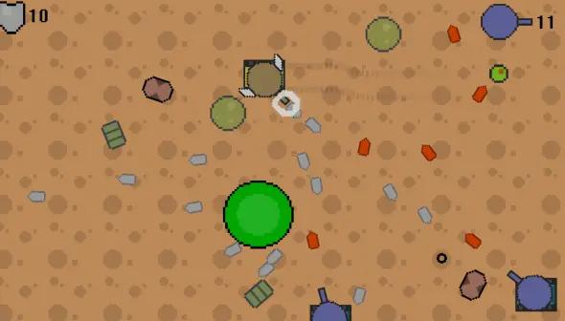
Seed: 12345
Same seed and settings produce the same layout.
Seed: 67890
A different seed produces a different layout.
These images illustrate the concept rather than actual output from your generator.
How it works in Unity
Random.InitState(12345);

int obstaclePosition = Random.Range(0, 10);
int anotherPosition = Random.Range(0, 10);
If you run this code again with the same seed and make the same random calls in the same order, you'll get the same results.
Change the seed, and the sequence changes.
Why this matters for your tank game:
- Debugging: Reproduce the exact battlefield where an enemy got stuck.
- Testing: Compare two gameplay changes on the same map.
- Replayability: Generate different maps across runs.
- Sharing: Save a seed to let someone else reproduce a particular map.
One important Unity detail: Random.InitState() resets Unity's global random generator. Other scripts using UnityEngine.Random can affect the sequence. For a reusable generation system, consider giving the generator its own System.Random instance so unrelated gameplay randomness doesn't change your map.
2. You're following Sunny Valley Studio's 2D dungeon generation tutorial
That gives us a useful starting point. The tutorial is focused on procedural dungeon generation, so it teaches concepts that transfer to your tank game, even though the final map structures might be different.
The key is understanding which parts are reusable and which parts are dungeon-specific.
Dungeon generation concept | Application to your tank game
Grid or tile-based map | Representing the battlefield
Randomized placement | Positioning obstacles and props
Room generation | Creating distinct combat zones, if needed
Corridors | Creating lanes between obstacles
Tilemap rendering | Drawing the generated battlefield
Random seed | Reproducing generated layouts
Connectivity checks | Ensuring areas remain reachable
Not every concept needs to make it into your game. If the tutorial generates rooms connected by corridors, you don't have to copy that design into an open tank arena. You can reuse the underlying techniques while changing the generation rules.
How I'd approach your implementation
Continue following the tutorial rather than interrupting it to build a general-purpose framework immediately.
- Finish the tutorial's generation logic.
- Understand how its map data and rendering work.
- Keep your working generator in its separate test scene.
- Identify the dungeon-specific assumptions.
- Adapt the generator to your tank battlefield and integrate it into the main scene.
Your longer-term goal of a reusable 2D map generator can come from this project, but first make one implementation work reliably.
The distinction to remember: procedural generation is the technique; a dungeon, tank arena, or survival map is the particular design built with it.
Seed like the minecraft seed
Exactly! It's the same concept as a Minecraft seed.
In Minecraft, you enter a seed and the game generates a particular world from it. In your tank game, the seed can determine how your battlefield is generated.
For example:
- Seed 12345: Obstacles appear in layout A.
- Seed 67890: Obstacles appear in layout B.
- Seed 12345 again: Layout A is reproduced, assuming the same generation logic, settings, and random-call sequence.
The same principle applies to your dungeon-generation tutorial.
The useful part for your tank game is that you can save a seed whenever a map produces an interesting or problematic encounter, then reproduce it to test your changes.
One difference: Minecraft's world generation is a much more complex system. A seed alone doesn't guarantee identical worlds across different game versions or generation settings. Your Unity generator has the same general limitation.
Think of the seed as the starting number that drives the world's randomness, not as a file containing the map itself.

